Lab Questions
Lab 1: Identify Entities and Attributes from a Flat File
Level
Beginner
Concepts Covered
- What is schema design?
- Entity identification
- Attributes
Problem Statement
You are given a CSV export from an e-commerce app that mixes order, customer, and product details in each row. Identify the candidate entities and list their key attributes.
Scenario / Input
Sample CSV rows (columns):
order_id, order_date, customer_name, customer_email, product_id, product_name, quantity, price, shipping_address
Example:
1001,2026-06-01,Jane Doe,jane@example.com,200,Widget A,2,19.99,"123 Elm St"
CopyExplain
Expected Output Format
- List of entities (one per line)
- For each entity, list 4–6 suggested attributes
Try It Yourself
Write your entity list and attributes before checking solutions.
Hint
Think about grouping attributes that repeat per customer, per order, and per product.

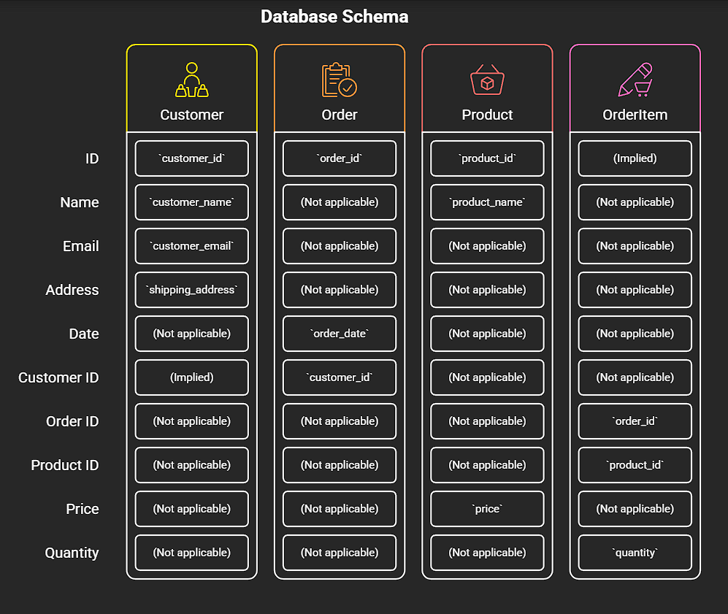
Lab 2: Classify Relationships and Keys
Level
Beginner
Concepts Covered
- Relationships (1
, 1
, N
)
- Primary key and foreign key recap
Problem Statement
Using entities from Lab 1, state relationship types and propose PK/FK for each table. Include examples where orders contain multiple products.
Scenario / Input
Entities: Customer, Order, Product, OrderItem
Expected Output Format
Table with columns: Entity, Primary Key, Foreign Keys, Relationship Notes
Try It Yourself
Sketch PK and FK choices and justify them briefly.
Hint
An Order can have many OrderItems; one OrderItem references one Product.

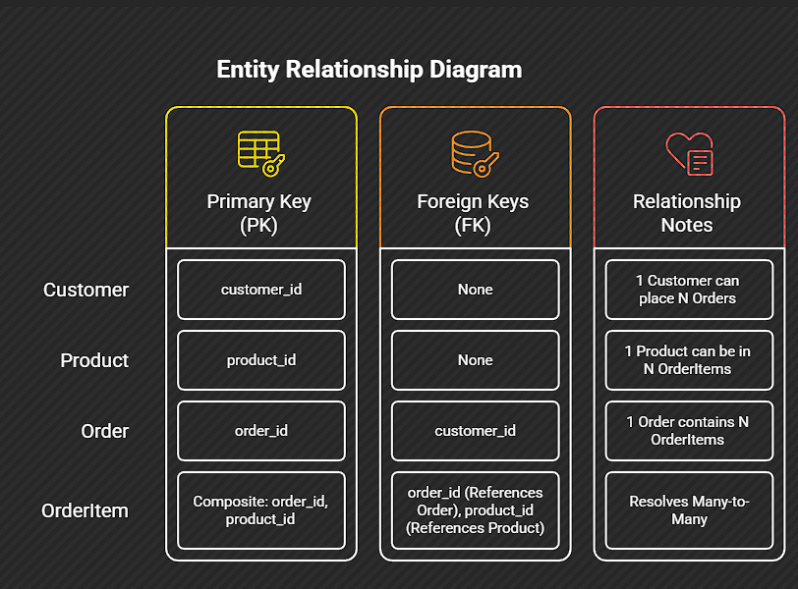
*----------------------------------------------------------------------------
Lab 3: Apply First Normal Form (1NF)
Level
Beginner
Concepts Covered
- First Normal Form (1NF)
- Removing repeating groups
Problem Statement
Transform the following denormalized row into 1NF rows.
Scenario / Input
One row:
order_id: 1002 customer: Bob Smith products: [ {"product_id"
,"qty"
}, {"product_id"
,"qty"
} ]
Expected Output Format
List of rows where each product is a separate row (show order_id, customer, product_id, qty).
Try It Yourself
Write the transformed rows.
Hint
Each row must be atomic—no arrays or nested lists.

1002, Bob Smith , 201 , 1
1002, Bob Smith , 201 , 999

*--------------------------------------------------------------------------
Lab 4: Convert Repeating Groups into Rows
Level
Beginner
Concepts Covered
- Repeating groups removal
- Simple Python transformation
Problem Statement
Given a small JSON list of orders with product arrays, flatten into OrderItem rows using Python.
Scenario / Input
orders = [ {"order_id":1003,"customer":"Ana","items":[{"product_id":301,"qty":2}]}, {"order_id":1004,"customer":"Ben","items":[{"product_id":302,"qty":1},{"product_id":303,"qty":4}]}]
CopyExplain
Expected Output Format
A Python list of dicts:
[{"order_id"
,"customer":"Ana","product_id"
,"qty"
}, ...]
Try It Yourself
Write Python code that transforms orders into item rows.
Hint
Use nested loops or list comprehensions.

[
{"order_id": 1003, "customer": "ana", "product_id": 301, "qty": 2},
{"order_id": 1004, "customer": "marciano", "product_id": 302, "qty": 1},
{"order_id": 1004, "customer": "marciano", "product_id": 303, "qty": 4}
]
*---------------------------------------------------------------------------------------------
Lab 5: Apply Second Normal Form (2NF)
Level
Intermediate
Concepts Covered
- Second Normal Form (2NF)
- Partial dependency elimination
Problem Statement
You have a table OrderItem(order_id, product_id, product_name, product_price, qty). Identify partial dependencies and split tables to reach 2NF.
Scenario / Input
Columns and sample rows:
order_id | product_id | product_name | product_price | qty1005 | 401 | Gizmo | 9.99 | 21005 | 402 | Doodad | 5.00 | 1
CopyExplain
Expected Output Format
List two or more tables with PKs and example rows.
Try It Yourself
Propose tables and show sample rows.
Hint
Product info depends on product_id, not on order_id.

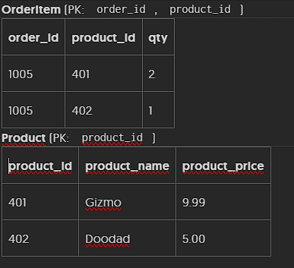
*------------------------------------------------
Lab 6: Apply Third Normal Form (3NF)
Level
Intermediate
Concepts Covered
- Third Normal Form (3NF)
- Transitive dependency removal
Problem Statement
Given Customer(customer_id, name, city, zip, state_name), identify transitive dependencies and suggest table splits to reach 3NF.
Scenario / Input
state_name depends on zip via zip->state mapping.
Expected Output Format
Normalized table designs showing PKs and FKs.
Try It Yourself
Produce 2–3 table definitions.
Hint
Move city/zip/state lookup to a separate table if zip determines state.

Pk customer_id,
Atributes: name, city, zip, state_name <--- Zip code would be FK

PK Zip
Attributes state_name
(honestly city should be part of the attributes of zip but since lab 6 states that statename it’s the only attribute of zip then it its.)

Lab 7: Design an OLTP Normalized Schema (Orders)
Level
Intermediate
Concepts Covered
- Normalized model for OLTP
- PK/FK, constraints
Problem Statement
Design a normalized OLTP schema for customers, orders, order_items, and products. Provide CREATE TABLE statements in SQL (simplified) with PK and FK constraints.
Scenario / Input
Assume typical e-commerce needs: enforce data integrity, avoid redundancy.
Expected Output Format
SQL CREATE TABLE statements for four tables.
Try It Yourself
Write CREATE TABLE statements using basic types.
Hint
Use surrogate integer keys for PKs; show foreign keys.
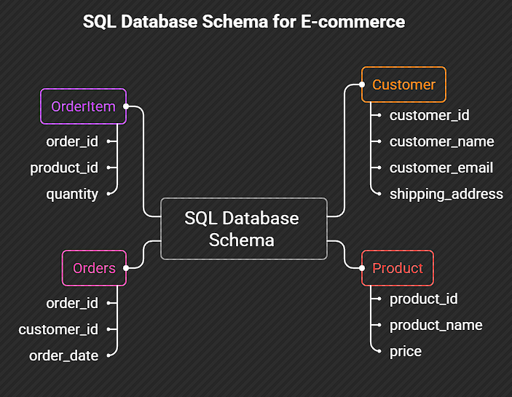

Lab 8: Create a Denormalized Reporting Table
Level
Intermediate
Concepts Covered
- Denormalization basics
- Reporting table design
Problem Statement
Create a denormalized daily orders reporting table that contains customer_name, order_id, order_date, total_order_value, product_list (as a single string), and shipping_city.
Scenario / Input
Sample normalized data (you can assume aggregation is needed).
Expected Output Format
Show CREATE TABLE for reporting and one sample INSERT/row produced by aggregation.
Try It Yourself
Design the reporting table and show an example aggregated row.
Hint
Product_list can be a comma-separated string for quick dashboards.
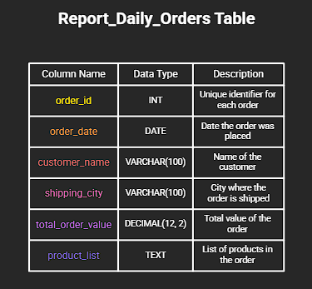

Lab 9: Design a Star Schema: Fact and Dimension Tables
Level
Intermediate
Concepts Covered
- Star schema introduction
- Fact tables
- Dimension tables
Problem Statement
Design a star schema for order analytics: FactOrders and dimensions CustomerDim, ProductDim, DateDim. Define grain, keys, and 5 sample columns for each.
Scenario / Input
Analytics use cases: daily sales by product category and customer region.
Expected Output Format
Table list with columns and brief explanation of grain.
Try It Yourself
Define primary keys for dims and foreign keys in the fact.
Hint
Fact grain: one row per order_item or per order (decide and justify).
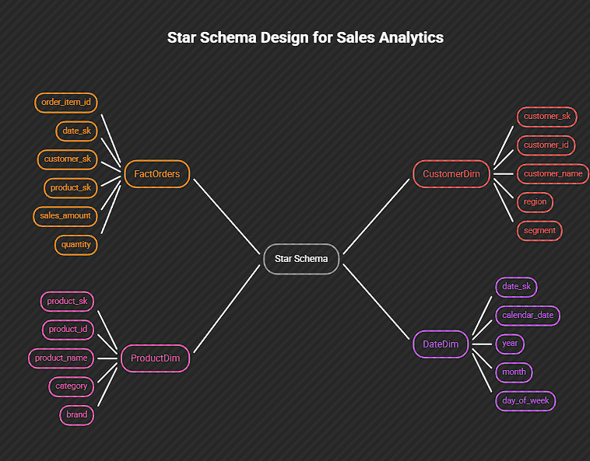

Lab 10: Map Normalized Data to Star Schema (ETL sketch)
Level
Intermediate
Concepts Covered
- ETL mapping
- Data transformation for analytics
Problem Statement
Sketch SQL/ pseudocode to load fact table from normalized OLTP tables: orders, order_items, products, customers. Include joins and aggregations for daily fact (one row per order_item with sales_amount).
Scenario / Input
Normalized tables available in the source schema.
Expected Output Format
SQL query or pseudocode that produces fact rows.
Try It Yourself
Write an INSERT INTO ... SELECT ... statement.
Hint
Compute sales_amount = qty * product_price.
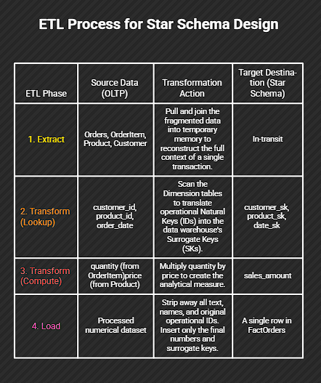

Lab 11: Model Slowly Changing Dimension (Type 2)
Level
Advanced
Concepts Covered
- Slowly Changing Dimensions (SCD)
- Type 2 implementation
Problem Statement
Design a CustomerDim that captures address history using Type 2 SCD. Show table columns and example rows demonstrating a customer moving city.
Scenario / Input
Customer 900 moved from "Oldtown" to "Newcity" on 2026-05-10.
Expected Output Format
Table definition and two sample rows showing versioning/history.
Try It Yourself
Decide on surrogate key, natural key, effective_from, effective_to, and current_flag.
Hint
Type 2 keeps history by inserting new rows, not updating.

Example Rows (Customer 900 moving on 2026-05-10):
customer_sk | customer_id | city | effective_from | effective_to | is_current
1045 | 900 | Oldtown | 2020-01-01 | 2026-05-10 | 0
1046 | 900 | Newcity | 2026-05-10 | 9999-12-31 | 1

Lab 12: Design for Query Performance: Denormalization Trade-offs
Level
Advanced
Concepts Covered
- Denormalization for performance
- Trade-offs (storage, updates, consistency)
Problem Statement
Given slow join-heavy reports, propose three denormalization changes to speed up queries and list the trade-offs for each.
Scenario / Input
Reports frequently join orders -> customers -> addresses -> product -> category.
Expected Output Format
List of 3 denormalization proposals with expected benefit and trade-off.
Try It Yourself
Rank proposals by read performance improvement.
Hint
Consider precomputed aggregates, wide reporting tables, and adding redundant columns.

Denormalization Trade-offs
Strategy | Benefit (Performance) | Trade-off (Cost)
1. Flat Table (One big table) | Zero joins; maximum read speed. | Massive storage bloat; data updates require rewriting millions of rows.
2. Materialized Views | Instant reads (joins are pre-computed). | Data is stale until refreshed; refreshing consumes heavy compute.
3. Push Text to Fact Table | Eliminates the most frequent joins. | Wider fact table; degrades insert (write) speed.

